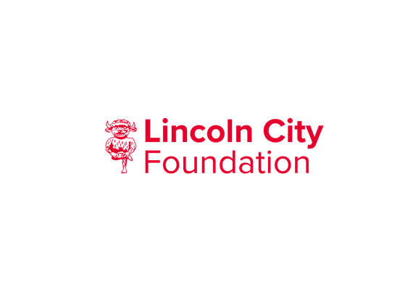

Gift Aid Declaration Form
Title
Initial
Surname
House Name
Address Line 1
Town
County
Postcode
Telephone
Number
Email
If you are a UK taxpayer, the value of your donations can increase by 25% under the Gift Aid scheme – at no additional cost to you! Please tick the box below to join the Gift Aid scheme.

I am a UK taxpayer*. Please treat all donations I make or have made to
Lincoln City Foundation for the past 4 years as Gift Aid donations until further notice. * Please be aware that you must have paid an amount of income and/or capital gains tax at least equal to the amount of tax reclaimed by all charities and Community Amateur Sports Clubs on all your donations in the tax year (6th April one year to 5th April the next). We can currently receive an extra 25p for every £1 you donate. Other taxes such as Council Tax and VAT do not qualify.
Please let us know if your tax circumstances or name/address change so that we can update our records.
Date:
It may be that having read the information on this form you feel that your donation does not qualify. If this is the case, please tick the relevant box below and return this form to us. This will ensure you are not asked to complete a Gift Aid form in the future, should you choose to support us again.

I cannot complete the Gift Aid form because:
I am not a UK taxpayer

I do not pay enough tax each year to cover the tax on the gift

Other (please state)

Please return your gift aid form along with your donation.

Thank you for your support
Lincoln City Foundation would also like to contact you about our work and activities and how you may support us.
To receive this information via email or a message to your mobile phone. Please tick the box Email [ ] Mobile [ ]
If you prefer to receive this information by post or telephone. Please tick this box [ ]
By providing us with any personal data you consent to the terms and conditions of our Privacy Policy available at: https://www.lincolncityfoundation.com/our-policies
As a valued supporter of Lincoln City Foundation we will treat your details very carefully and will not pass them on to any other organisations.
If you change your mind you can unsubscribe at any time by contacting us at enquiries@lincolncityfoundation.co.uk or call 01522 563792.

Gift Aid Key Facts
When Lincoln City Foundation receives a donation from a UK taxpayer, we are entitled to claim an amount of tax (calculated at the basic rate of income tax in that year) paid on that donation. Once you have given your permission for us to do this on your behalf (by filling in this Gift Aid form), there is no need for you to do anything else.
All that is required is that the amount of income and/or capital gains tax you pay in a given tax year (6th April one year to 5th April next year) is at least equal to the amount of tax claimed by all charities and Community Amateur Sports Clubs on all your donations. As this amount is calculated over the whole tax year, there is no requirement that tax is paid regularly – it is purely a question of how much has been paid in the tax year. Other taxes such as Council Tax or VAT do not qualify for Gift Aid.
The amount of tax we claim will be 25% of the total value of your donations in that tax year. Furthermore, if you are a higher taxpayer, you are also entitled to claim the difference between the basic rate which we will claim and the amount of tax you have actually paid. For further details on how you can do this, please contact your tax office. If your tax situation changes and your gifts will no longer be eligible for the Gift Aid scheme, please contact us and we will amend your record accordingly.

